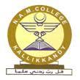
DEPARTMENT OF COMPUTER SCIENCE
N .A. M. COLLEGE KALLIKKANDY

RESULT STATISTICS
UG Course (B.Sc. Computer Science)
YEAR | NO. OF STUDENTS APPLIED | NO. OF STUDENTS PASSED | PASS %
2016-17 | 29 | 18 | 62%

