2019-20

1)ESPEDIDA-Merit Day Date: 13/06/19
On behalf of the Department of Polymer Chemistry, Merit Day ”ESPEDIDA” was held on 13/06/19 Thursday at college auditorium, congratulating the graduates of academic year 2016-19.The welcome address was given by Abdul Jaleel M.V. Smt Shabna.K K, Head of the Dept of Polymer Chemistry (in charge) presided over the function and Dr.MuhammadKutty,Principal of N.A.M College inaugurated the Merit Day
Mementoes were distributed to graduates by the Principal.Sri.Namshad.KP ,Asst.Professor of Polymer Chemistry and Dr.Madhusoodhanan MK ,Head of the Dept Of Physical Education, felicitated the programme. All the students shared their beautiful memories about their college life. The topper got awarded a scholarship for the higher studies by the Principal. A cultural programme followed the function. Vote of the thanks was offered by Jasna,2nd year polymer Chemistry Student
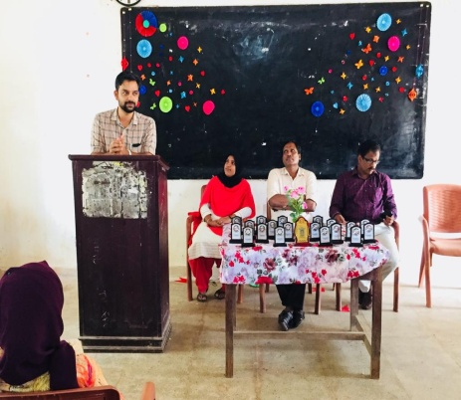 | 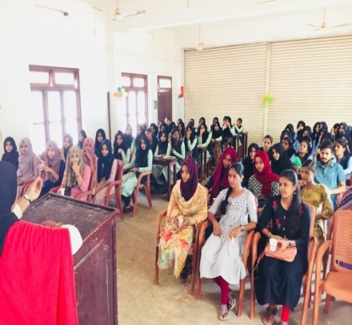
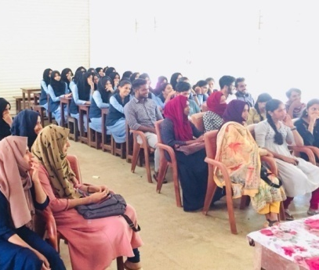 | 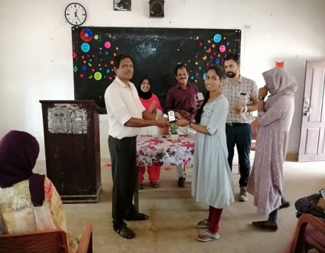
ESPEDIDA-Merit Day
2) One day training and awareness programme on water quality testing
Date :05- 07- 2019.
The training was conducted by Mr. Abdul Rasheed .C (Junior research fellow, CWRDM, Calicut), aiming to give training and awareness on the importance of water purity in the era of water scarcity and lack of pure potable water.
3) One Day Workshop on detergent and dish wash making
Date:11th-07-2019.
EXPLORICA – a one day workshop on how to make dish wash and detergent was conducted on 11th July 2019 by the Dept of Polymer Chemisty. .Sri.Namshad.KP,Asst Professor of Polymer Chemistry, welcomed the gathering,.Smt.Anusree K,Head of the Department (in charge) delivered the presidential address. Dr.TMajeesh, Principal in charge of NAM College, inaugurated the programme and congratulated the chief guest, Habeeba Patyeripoyil, a young entrepreneur and an alumni of NAM College, for her successful business venture. The chief guest, Habeeba shared her business secret and trained the students to make detergent and dish wash.Vote of thanks was proposed by FathimathNasriyya, Second year Polymer chemistry student.
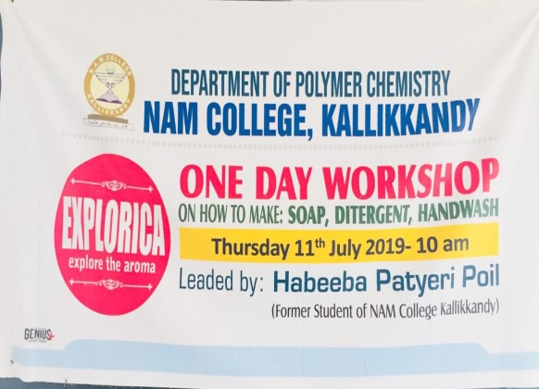 | 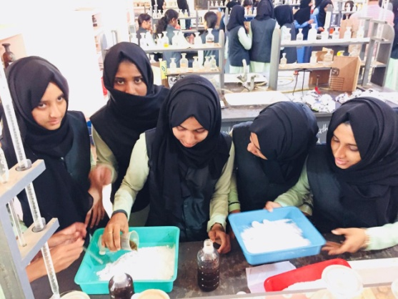
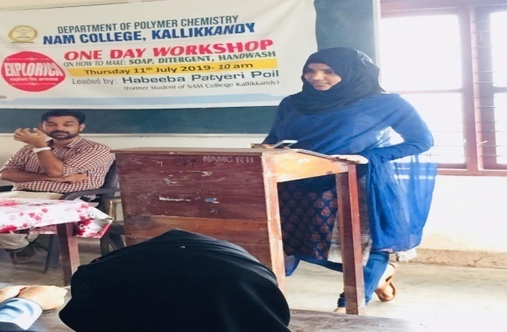 | 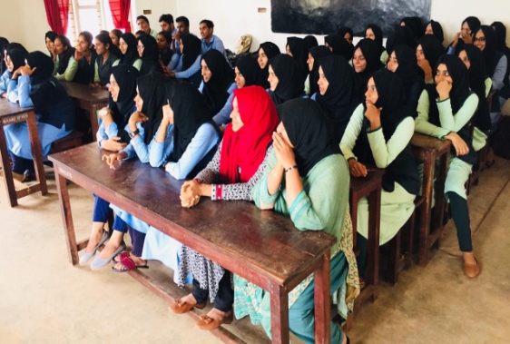
One Day Workshop on detergent and dish wash making
4)Anti-Drugday Celebration
Date:26th-07-2019.
Sri. Namshad K P, Assistant Professor of Polymer Chemistry made the students aware of the adverse effects of the use of drugs to human health and also to the society. He motivated the students to work hard to wipe out drugs from society. Everyone took pledge to fight against drug use.
5)Ozone DayCelebration
Date:24-09-2019
Ozone Day was celebrates on 24th September 2019, by the financial support of KSCSTE. A workshop on making eco-friendly items like paper pen, paper bags was also conducted in connection with this programme.
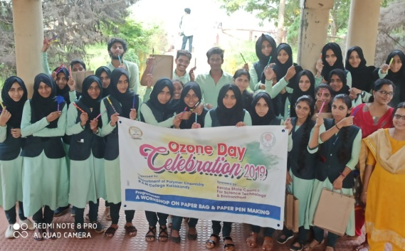 | 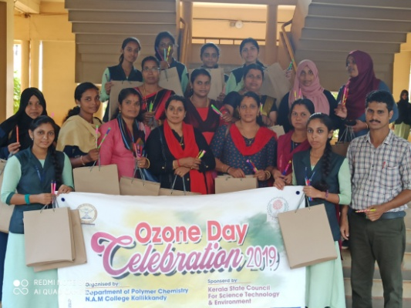
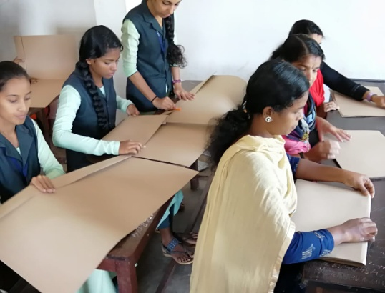 | 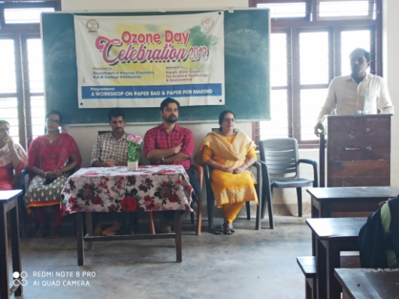
Ozone Day Celebration
6) Workshop on Google Classroom
Date:15-11-2019
A workshop on Google Classroom was conducted by the Department of Polymer Chemistry, in association with NAM College Library. Sri.MunfarKappil,UGC Librarian handled the session and Sri.Namshad.KP ,Asst Professor,Dept of Polymer Chemisrty provided them a practical session on Google Classroom.Vote of thanks was proposed by Fathimathul Shamiha, (II BSc PC).
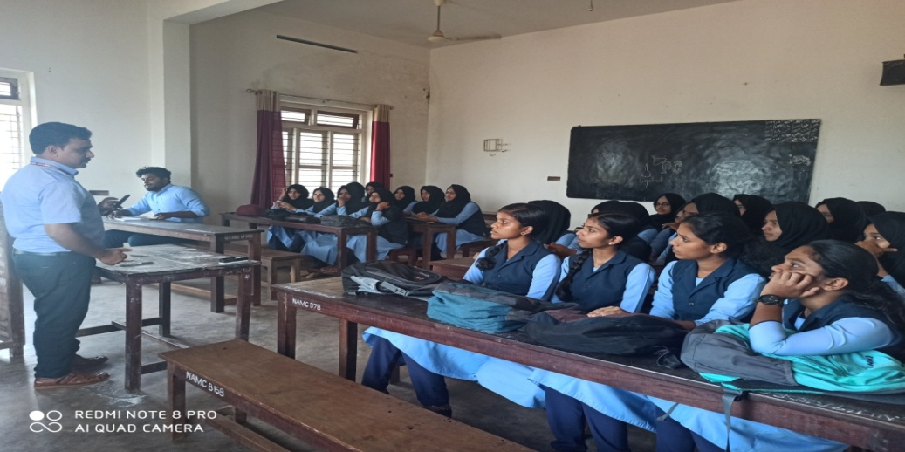
Workshop on Google Classroom

