HISTORY DEPARTMENT
Association Inauguration
History Association 2019-20 inaugurated by Shiju R, member of Malayala Aikyavedi state Committee on 13th December 2019. the program was presided over by Jose M.V., head of the department. Principal KK. Muhammed Kutty distributed certificate to those students participated in departmental extension program held at Thuvakunnu LP School in the tragic memory of Hiroshima and Nagasaki day on August 9. Dr. Joy Varkey, Dr. Muneera Beebi, Anas E, Prabeena and Ali K delivered the felicitation address. Shahana P, Association Secretary delivered the vote of thanks.
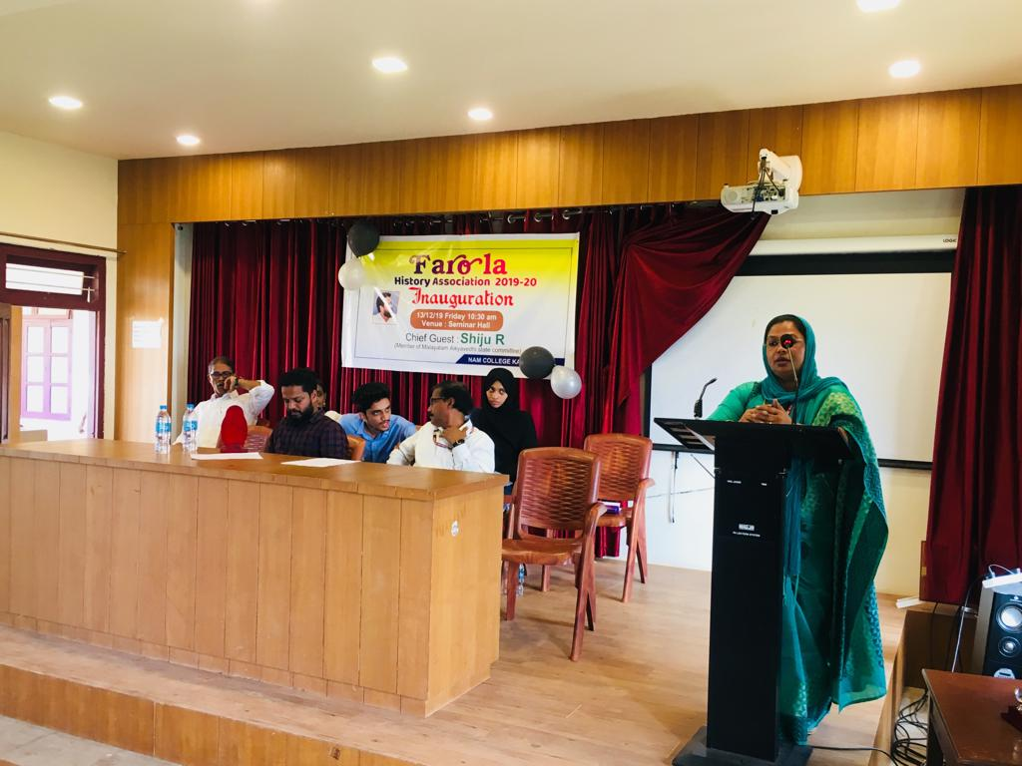
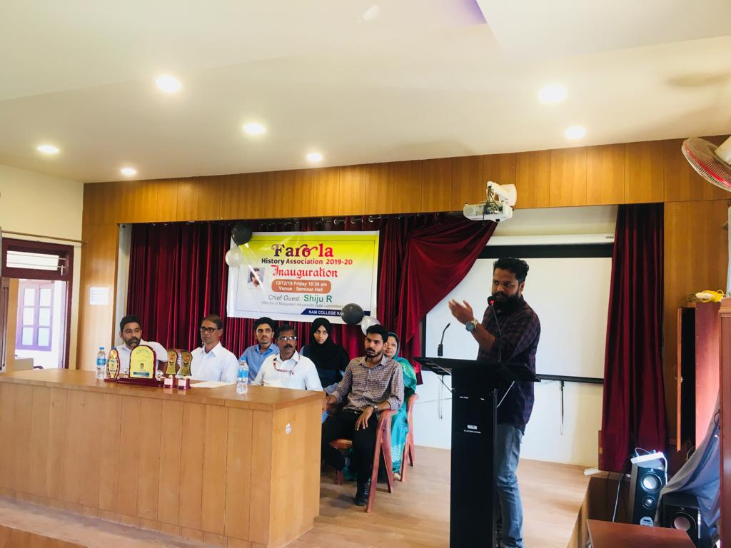

Silver Jubilee Research Project
A field trip to Narikkottumala was arranged as part of Silver Jubile Reserach project titled ' Exploring Narikkottumala Locality: A Study on the Socio- Economic Transformation of Kurichya Tribe'. the field trip held under the guidance of Dr. Joy Varkey and twelve students from first and second years students from department of history.
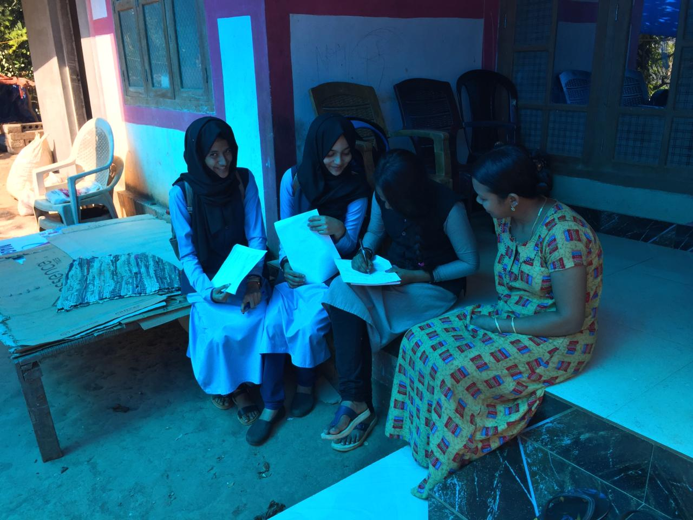
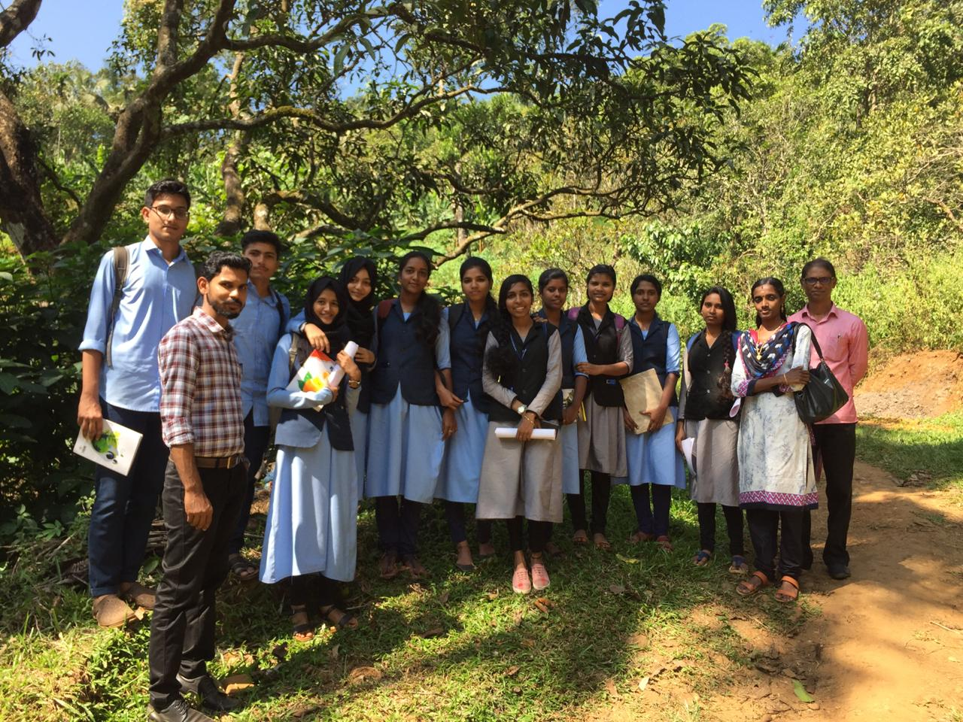

Academic extension program at Thuvakkunnu LP School
Department of history organised an academic extension program at THuvakkunnu LP school on 9th August as part of the Hiroshima and Nagasaki day. The theme of the program was ‘peace on earth: Hiroshima and Nagasaki never again’. The function presided over by Dr. Muneera Beebi, associate professor, department of Sociology, and inagurated by Dr. Joy Varkey, associate professor, department of history. The students from the department of history interacted with students on various topics.

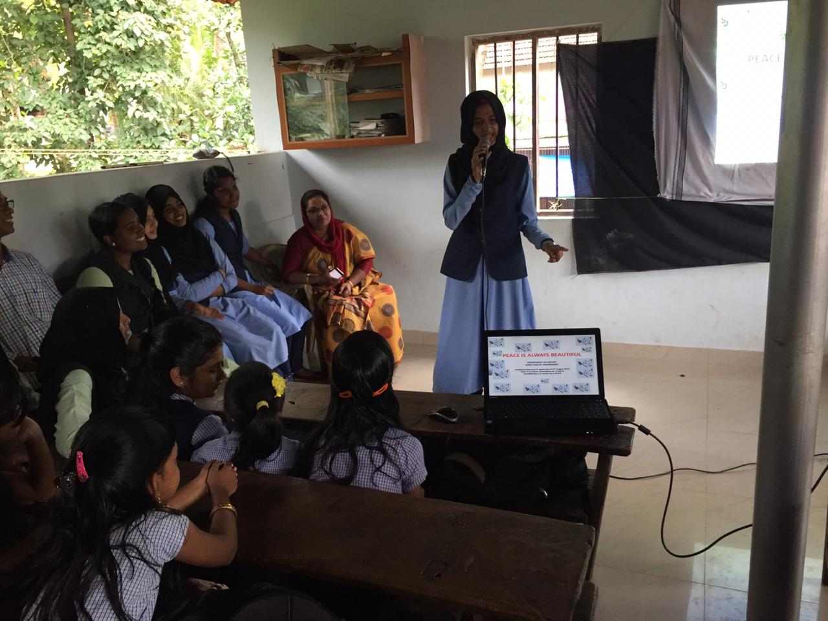
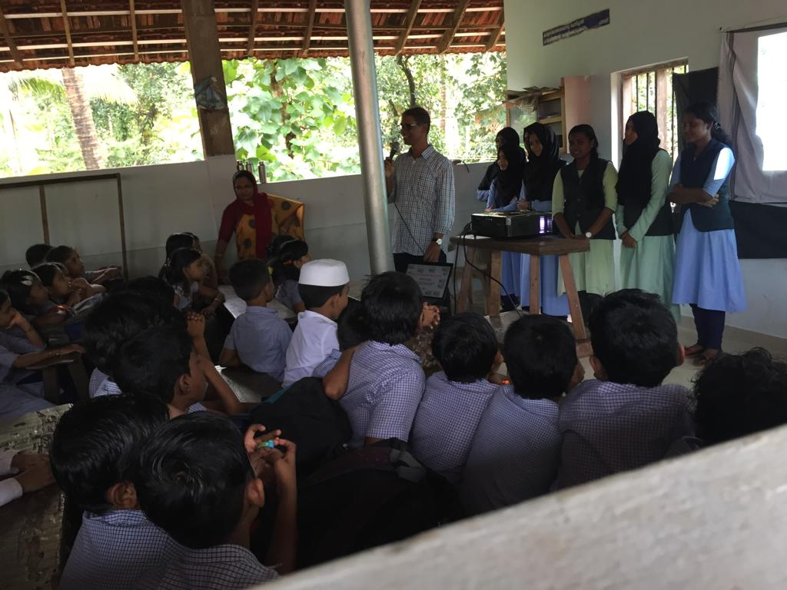

Seminar on Gandhiji and Indian Nationalism
Department of history organaised one day seminar on ‘Gandhiji and Indian nationalism’on 1st october on behalf of 150th birthday of Mahatma Gandhiji. Dr. Jose MV.,Head of the Department, presided over the function and inaugurated by Dr. muhammed Kutty, Principal NAM College. Dr. Muneera Beebi and Tharique, union chairman, facilitated the function.Students from department of history presented paper on the topic. Shana PP, history assosiation chairman, delivered the vote of thanks.
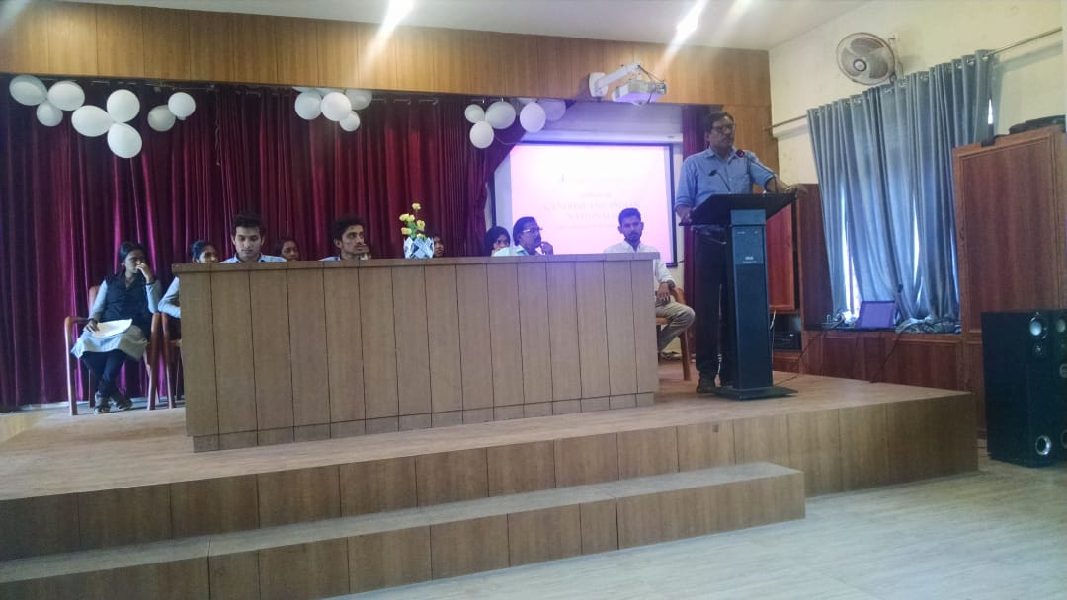
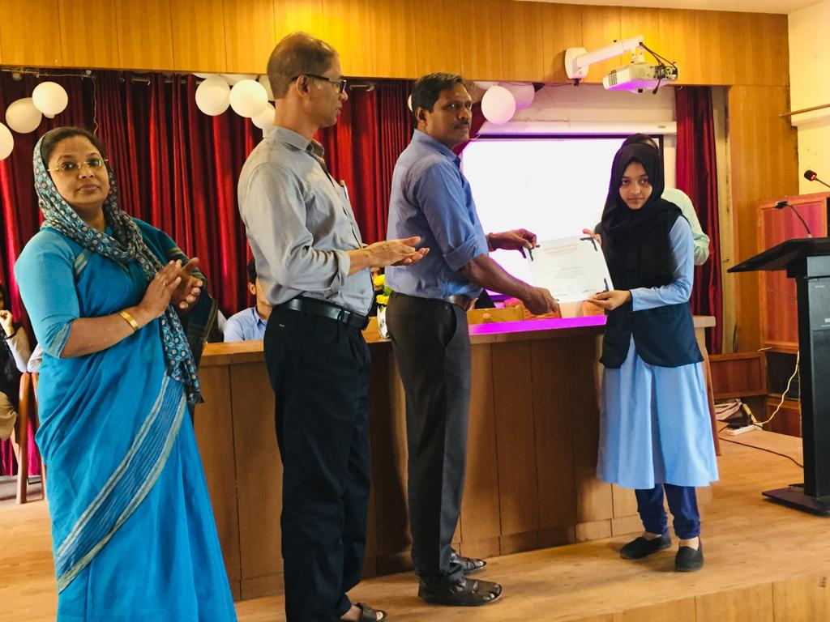
Twenty Twenty Quiz Competition
Department of History conducted a Quiz program in association with History association on 24th January 2020ndian Constitution based on Indian constitution. Dr.Joy Varkey led the competition with strange questions in this field. Sahalth M, Fathimath Suhara V.P. and Sana Sadique from Department of History won the first, second and third prize respectively.
Felicitation Ceremony
Department of History arranged a felicitation ceremony to congrat Miss Naflah Faisal for combiling a poetric work named ‘Madil’. The program inaugurated by the Principal Dr. KK.Muhammed Kutt and Fecilitated Naflah Faisal by handing over the Memento. Dr. Jose MV, Head of the Department Dr. Joy Varkey and Dr. Muneera Beebi felicitated the program. Certificates were distributed in the session to those students who participated in different academic program.
Extension Program
Dr. Joy Varkey participated in a program at Thuvakkunnu UP School on the topic ‘Indian Constitution. He gave a detailed message about the Indian constitution and gave answer for the queries of the students and gave motivation to them to achieve a big goals.

