ASSOCIATION INAUGURATION 2017-18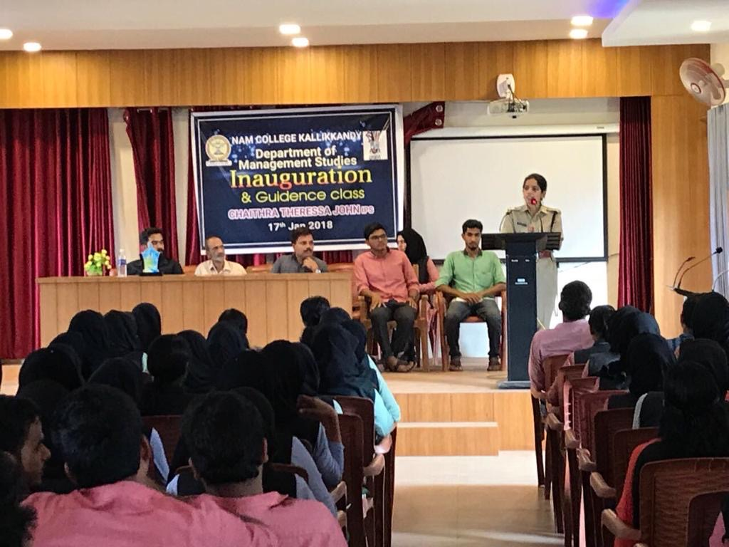
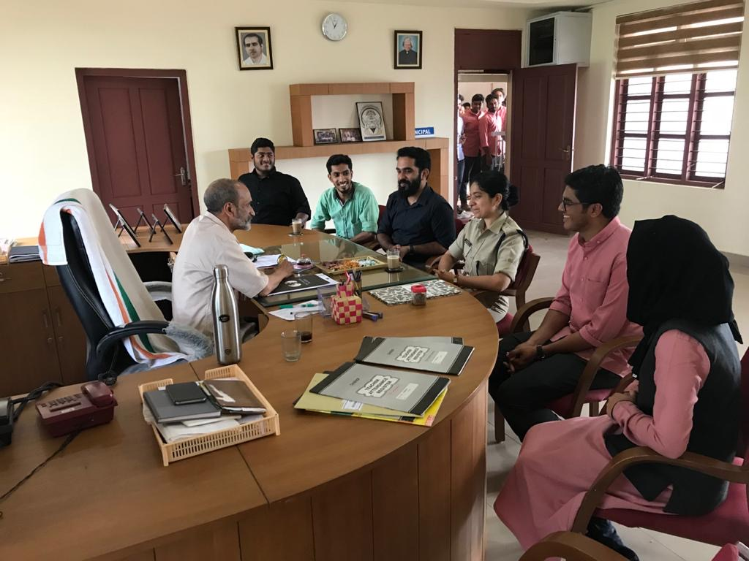
The foremost association was inaugurated by Smt. Chaithra Theresa John IPS, Assistant Superintend of Police, Thalassery on January 17, 2018. The programme was presided by Akbar Mohammad Jamal, Head of the Department and Principal Dr.K.K. Mustafa delivered the keynote address. Association secretary Rizwana, Staff Advisor C.V. Gafoor, Students Union Chairman Shemin Shahras, Secretary Raoof felicitated the function. The programme concluded with a guidance class by the inaugurator regarding the participation of women into civil service vacancies of the state.

