POSTGRADUATE DEPARTMENT OF COMMERCE
NAM COLLEGE KALLIKKANDY

PROGRAMME REPORT
2021-2022

Swadhayam (Reading Week Celebration)
The department of commerce in association with IQAC and college library observed the reading week celebration. The programme was held during 19/06/21 to 25/06/21.Various programmes have been conducted as the part of the celebration. The students of the college have participated in different online competitions. Competitions include Book review, poster making, quotes making, tongue twister, pronunciation of words, poem recitation, Mallu talk, Pictionary game etc. The cash prizes were distributed to the winners.
On 21/06/2021 a webinar was conducted on ‘Mahamari Kalathe Vayana’ as a part of reading week celebration. Mr. Veeran Kutty (well known Malayalam poet) delivered a presentation on the topic. Miss. Siyona Sudheesh (2nd year, B.Com) welcomed the gathering. Dr. Majeesh T (H O D of Commerce) has presided over the function. The programme was inaugurated by the Principal Dr. Muhammed Kutty K.K . Dr. Muhammed Ismail K, IQAC Cordinator and Mr. Munafar Kappil, UGC Librarian delivered felicitation speech. Mr. Sachin Chand (2nd year B.Com) proposed vote of thanks.
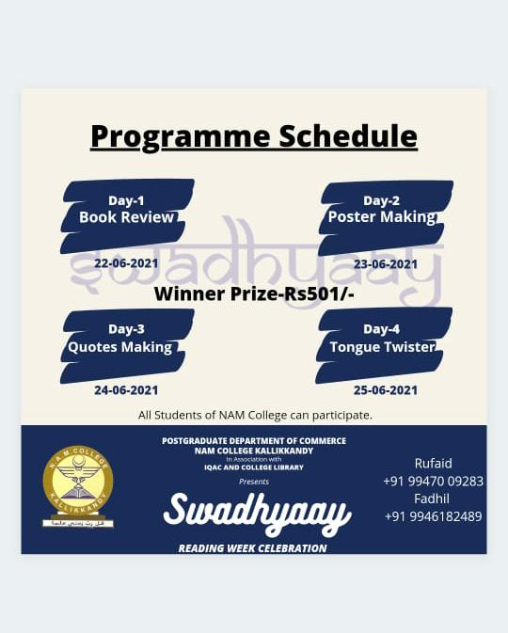
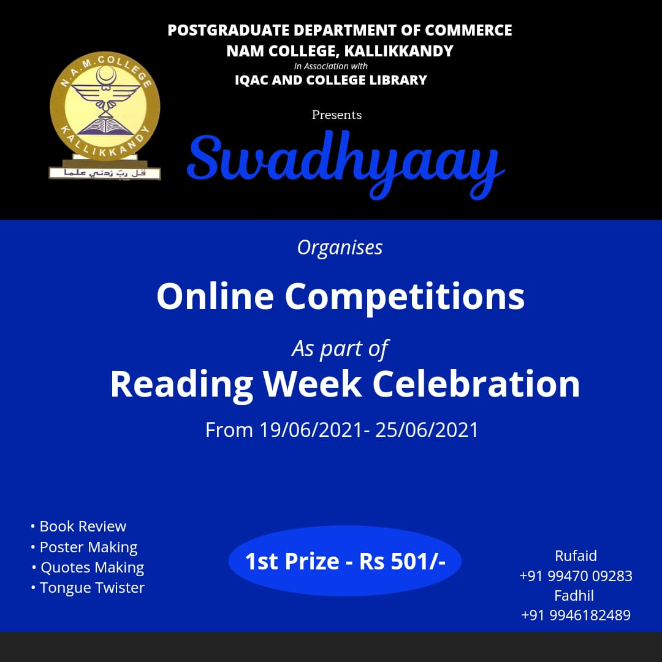
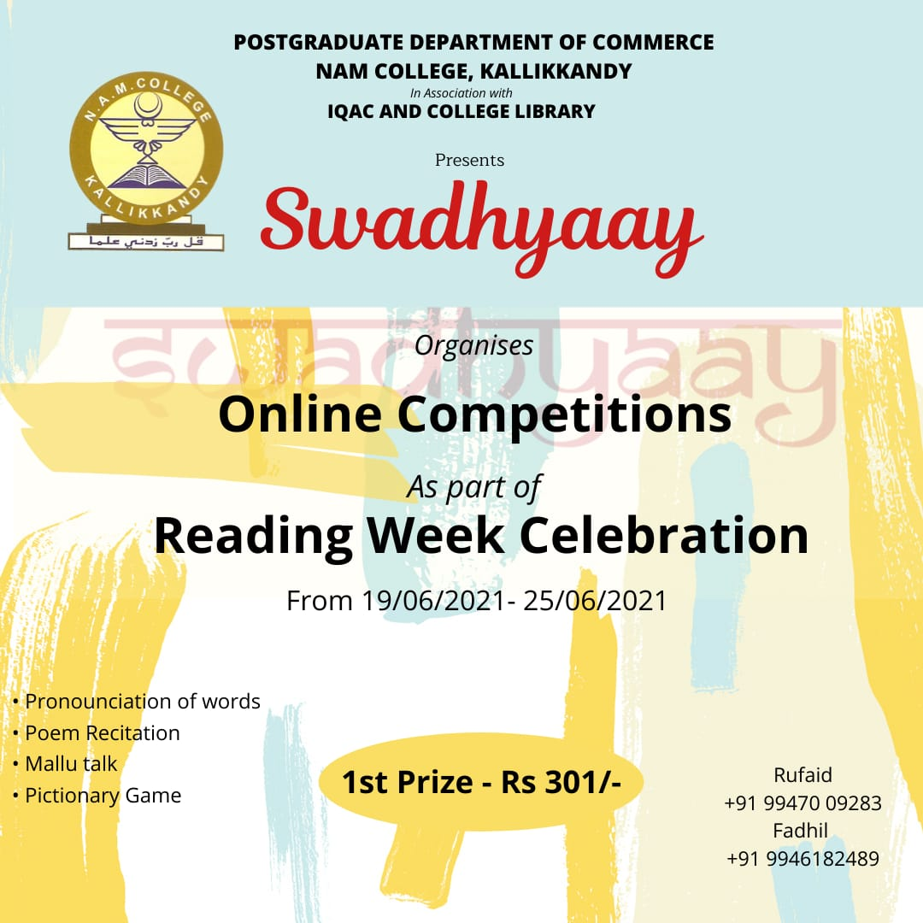
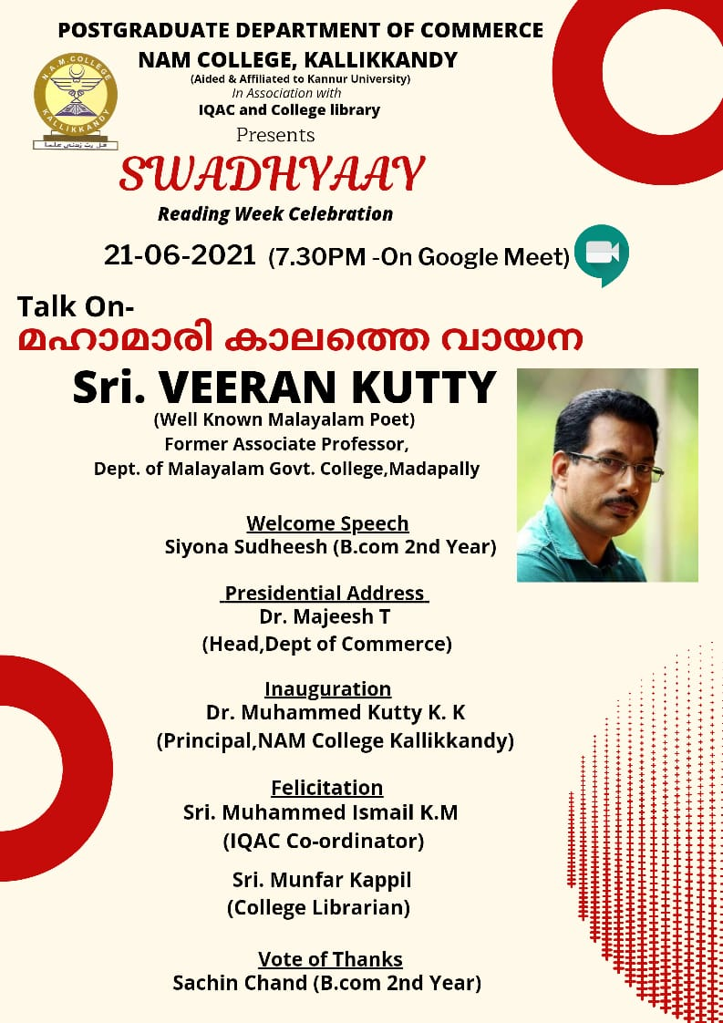
Webinar on ‘Importance of Soft skills in personal and professional life & job opportunities in current scenario’
The department of Commerce and Avodha group have jointly organised one day webinar entitled ‘Importance of Soft skills in personal and professional life & job opportunities in current scenario’. The programme was held on 29th June 2021.The programme was intended to selected students of BBA, B.Com and M.Com. Ms. Suhaila Hashim (Career Expert) was the resource person of the programme. The webinar discussed the importance of soft skill for the development of professional skill. Certificates were given to the participants.
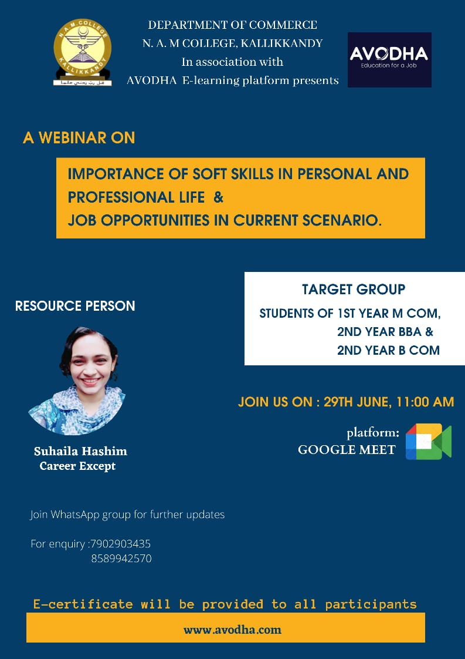

10 Days Training on Stock Market
The Department of Commerce in Association with SIAS Research Forum jointly organized 10 days online training Programme on Stock Market. The training was held during 01 October to 10 October 2021. 40 members have attended the inauguration session. The training session discussed the basic terms of stock market and mode of operation in the stock market.
Programme Schedule
Welcome : Arif MK (Programme Cordinator)
Presidential Address : Dr. Majeesh T (H O D of Commerce)
Inauguration : Dr. Muhammed Kutty KK (Principal, N A M
College, Kallikkandy)
Introduction about SIAS Research Forum : Dr. Sabeel Pulikkal
Topic Presentation : Dr. V L Mangesh (Financial Analyst)
Course Syllabus/Module
Day 1:
Why Invest? • Why we need to invest? • Direct and Indirect Investing • Stock Market myths and facts • How market works, types of markets, • Stock Exchanges (NSE, BSE), • Market Intermediaries (NSDL, CDSL) • Mutual Funds, NPS • Role of Regulator (SEBI), PFRDA, RBI
Day 2:
Market Tools and Terminologies • LTCG, STCG, Dividend, FD • Market Timings: Pre-Open Market Session • Market Players: FII, DII, QIB HNI, NRI, RI • Trading systems: Open Outcry, Electronic, Algorithmic. • Corporate: AGM, Board meetings • Equity issues: IPO, FPO, Rights, Bonus, Stock split • Platform: Demat account, Trading account, Bank a/c • Tools: Buy, Sell, Bid, Ask, Order Types, Contract Note. • Market Trends: Bull market, Bear market, • Market Strategies: Long, short, Intraday trading, Leverage, short sell, arbitrage, block deals, options and futures. • Market Protection: Guaranteed settlement, Circuit Filters, share auction, margin money. • Market Capitalisation and Sectors. • Indices: Sensex, Nifty, S&P, Sectoral Indices Liquidity: Share pledging • Global Markets

Day 3 :
Fundamental Analysis-1 • Balance Sheet Analysis • Profit and Loss Statement Analysis
Day 4 :
Fundamental Analysis-2 • Ratio Analysis • Application of Ratio Analysis in Stock Selection
Day 5 :
Value Investing • Selecting Blue Chip Stocks (Using Fundamental Analysis) • Identifying Multi Baggers • Portfolio Construction
Day 6 :
Behavioural Finance • Attributes to be a good investor • Attributes to be a long-term successful investor
Day 7 :
IPOs • How to analyse an IPO • How to practically apply for IPOs
Day 8 :
Technical analysis • Support and Resistance, • Indicators like VWAP, MACD, • Moving averages etc.
Day 9 :
Technical analysis • Strategies like OHL, ORB, PRB etc.
Day 10 :
Hands-On-Training in Zerodha and Upstox
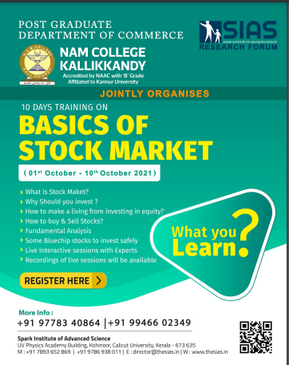

International Webinar
The department of commerce organized one day international webinar on 16/10/2021. The major objective of webinar was to discuss the recent innovations in the field of commerce and management. The meeting was inaugurated by the principal Dr. Muhammed kuttty kakkakkunnan. The programme was presided over by Dr.Majeesh T (Head of the PG Department of commerce). It was organized in two sessions. The topic of the first session was “Leading Innovations: A Promise to Progress”. The sessions was handled by Dr. Mahesh Ramakrishna Pillai (former dean, COBA, Umm Al Quwain University, UAE). He briefed the participants about the importance of innovations in the field of business. He also explained the success stories of some ventures and the circumstances of starting that ventures. The session was informative to the students.
The second session was handled by Dr. Musthaq Ahammed, Asst. Professor, Umm Al Quwain University, UAE ). The session was about “Cryptocurrency”. The resource person explained the pros and cons of investing in the cryptocurrency. The session was highly useful to the participants.
Dr. Ashraf (faculty member and convener of the webinar welcomed the gathering and Mr. Arif MK (faculty member) proposed the vote of thanks. More than 130 participants including faculty members and students of different colleges have attended the programme.
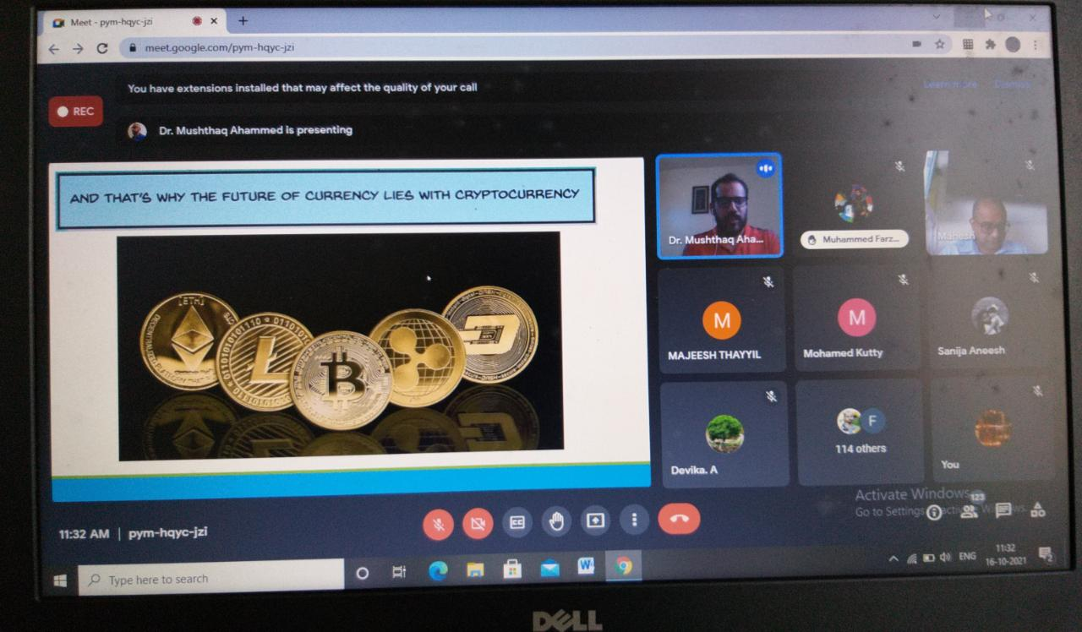
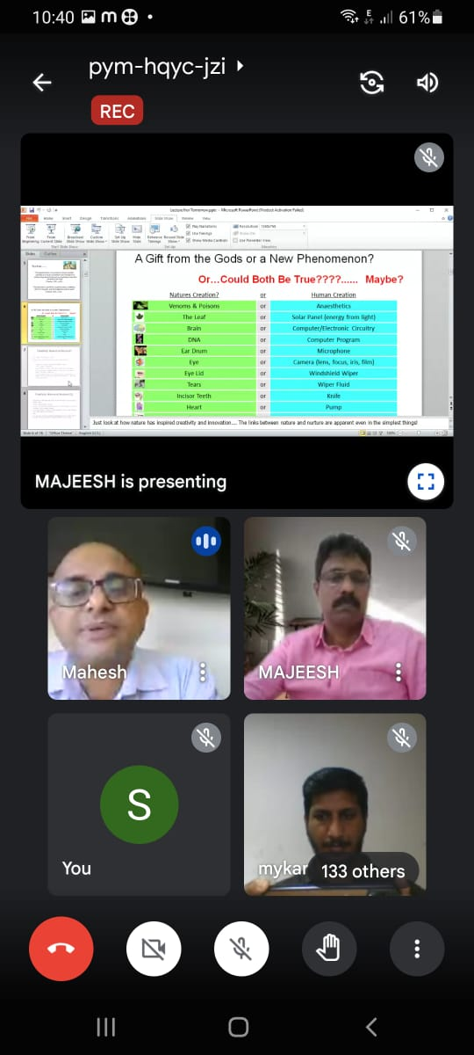
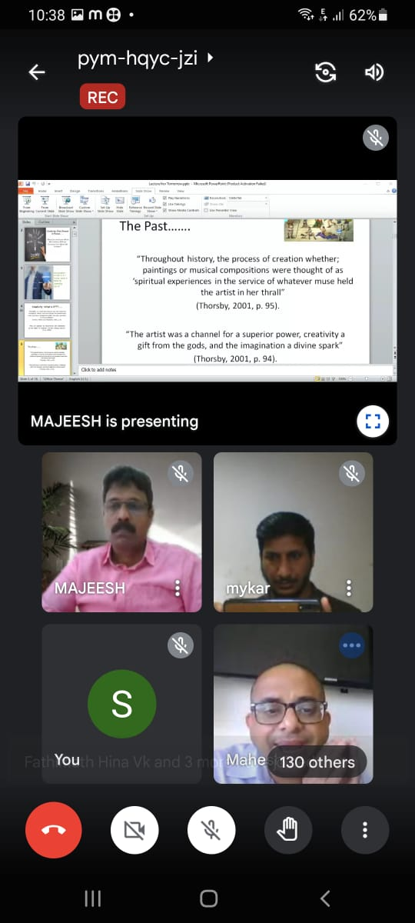

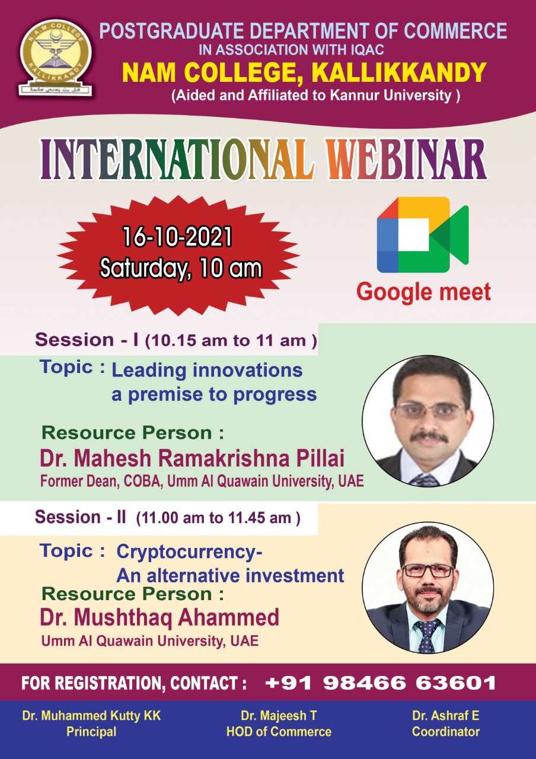
NATIONAL WEBINAR ON
INTELLECTUAL PROPERTY RIGHTS
19th and 21st February 2022
The department of commerce organized two day national webinar on 19th and 21st February 2022. The major objective of webinar was to explain the importance of Intellectual Property Rights. The webinar was inaugurated by the principal Dr. Muhammed kuttty kakkakkunnan. The programme was presided over by Dr.Majeesh T (Head of the PG Department of commerce). The session was handled by Dr. Anson C J (Asst. Professor Inter University centre for IPR studies, CUSAT. Dr. Ashraf E , faculty member and convener of the webinar welcomed the gathering and Ms. Akshaya Surendran (M.Com ) proposed the vote of thanks. More than 120 participants including faculty members and students of different colleges have attended the programme.

