**Webinar on ‘Gender of History and History of Gender’**

Department of History organized a webinar on ‘Gender of History and History of Gender’ on 7th September 2020. Dr. Anas Edoli delivered the welcome speech. The program was presided over by Dr. Jose M.V., HOD of the Department and inaugurated by Principal Dr. Mohammed Kutty. Dr. K.M. Sheeba, Professor, Department of History, SSSU, Kalady delivered the keynote address. Dr. Munira Beebi and Dr. Joy Varkey delivered the felicitational address. Naflah Faisal delivered the vote of thanks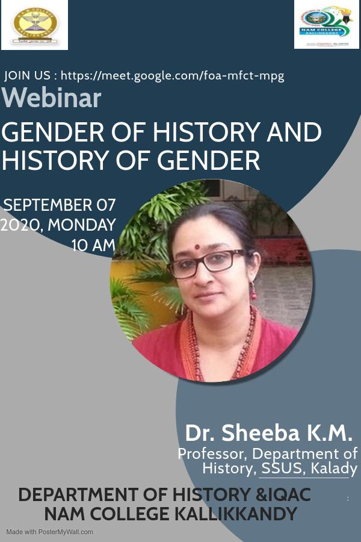

**MoU Signed with Moyinkutty Vaidyar Smaraka Mappila Kala Academy**

Department of History, NAM, College signed MoU with Mappila Kala Academy Sub-Center Nadapuram on 4 November 2020 at the regional office of the Academy, Nadapuram. Principal Dr. Mohamed Kutty and Dr. Jose M.V. signed the MoU on the part of College and V.C. Iqbal, Chairman, Mappila Kala Academy and C.H. Mohanan, Secretary, Mappila Kala Academy, signed the MoU on behalf of the Academy. Dr.Joy Varkey, Dr. Munir Beebi, Mr. Munfar Kappil and Dr. Anas Edoli presented in the event. The main objectives of collaboration are to promote cooperation in education and knowledge production, foster the development of original source based research and create an innovative platform for intellectual interactions between academia and public forumsC:\Users\ANAS EDOLI\Downloads\PHOTO-2020-11-05-12-46-43.jpg

**Webinar series on ‘Resistance Movements in Malabar: Revisiting the Historical Past’.**

The Department of History and Moyinkutty Smaraka Mappila Kala Academy organized a webinar series on ‘Resistance Movements in Malabar: Revisiting the Historical Past’. The webinar series was inaugurated by Husain Randathani, Chairman, Moyinkutty Vaidyar Smaraka Mappila Academy. Dr. Jose M.V., head of the department delivered the welcome speech and principal Mohammed Kutty presided over the function. Dr. Joy Varkey, Dr, Munira Beebi and Dr. Anas Edoli delivered the felicitation address.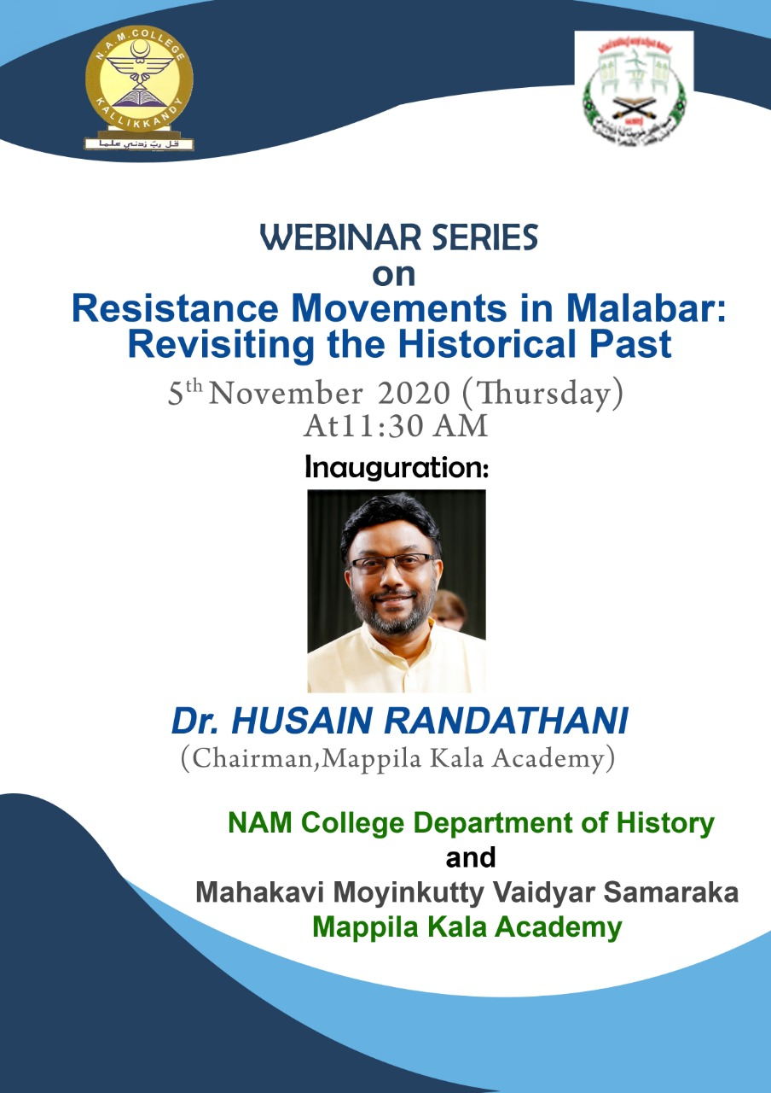

**Certificate Course on Archeology**

Department of History Started new Certificate course on Archeology. The course focuses only on Archeology and on various aspects of Excavation methods. For pursuing this course, all students must complete class 12th higher school certificate/graduation in History/ Diploma or any other History related course with a minimum 50% of marks from any recognized board.

**Webinar on ‘Resistance Movements in Malabar: Gender Perspectives’**

The Department of History conducted a Webinar on ‘Resistance Movements in Malabar: Gender Perspectives’ in order to enhance the knowledge of the faculty and students in this field. Dr. Shamshad Husain, the Chief Guest, is a professor at SSUS, Kalady and an expert in the area of Malabar History. At the beginning, Dr.Anas Edoli, Assistant Professor of History gave a welcome address to the participants and Dr.Jose M.V. presided over the function. Principal Mohammed Kutty delivered the inaugural address and Dr. Joy Varkey and Munira Beebi delivered the felicitation address. Sreechandana, second year student of the department, delivered the vote of thanks.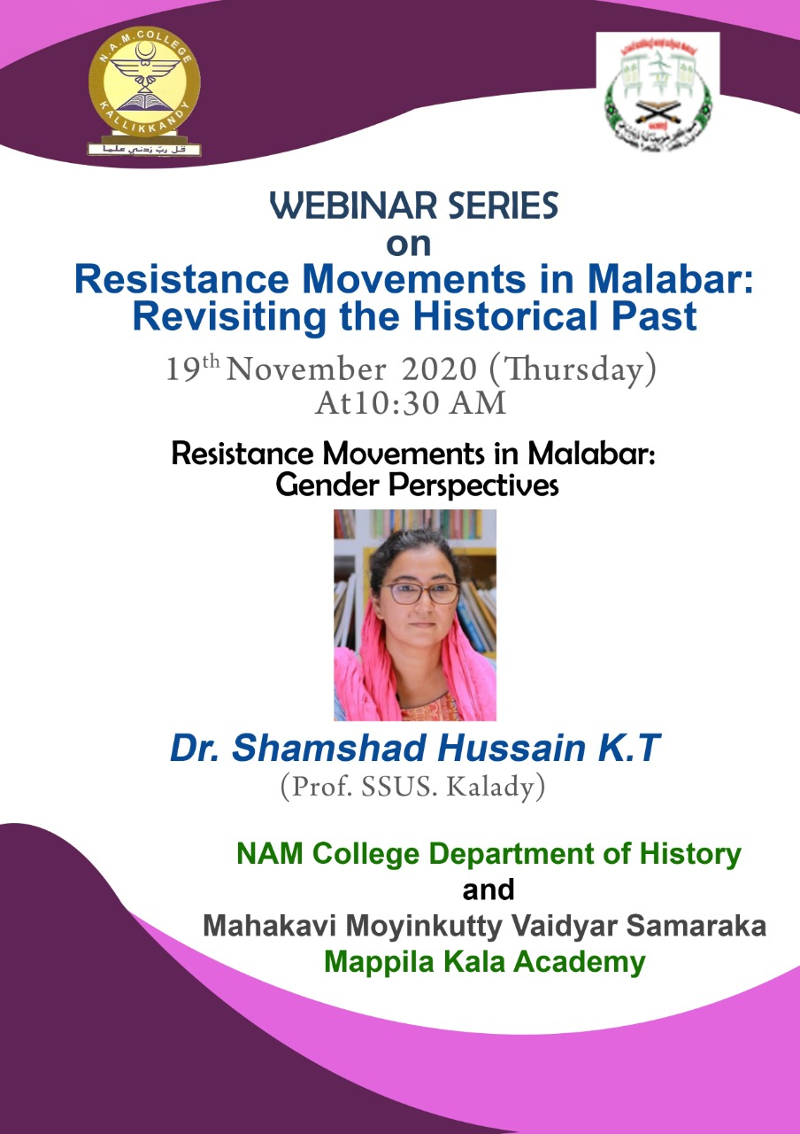

**Webinar on ‘Pazhassi Revolts: Conceptualizing Early Resistance Movements’**

The Department of History conducted a Webinar on ‘Pazhassi Revolts: Conceptualizing Early Resistance Movements’. Dr. Mujeebu Rahiman, the Chief Guest, is a professor at University of Calicut and an expert in the area of modern Kerala History. Dr.Joy Varkey, Associate Professor of History gave a welcome address to the participants and Dr.Jose M.V. presided over the function. Principal Mohammed Kutty inaugurated the function and Dr. Munira Beebi delivered the felicitational address. A second year student of the department, delivered the vote of thanks.

**International Seminar on ‘Arab Diaspora in Malabar: Mercantile Exchanges and Cultural Confluences’**

An International Seminar on ‘Arab Diaspora in Malabar: Mercantile Exchanges and Cultural Confluences’ was held on 1st March, Monday, at the Seminar Hall, N AM College Kallikkandy under the aegis of Department of History. The session began with the welcome speech delivered by Dr. Joy Varkey, Associate Professor, Department of History. This was followed by the Inauguration by the Principal Dr. Mohammed Kutty. Dr Jose M.V. presided over the function. The keynote address was given by Dr Saeed T.V., Associate Professor, Yobe State University, Nigeria. Dr Munira Beebi delivered the felicitational address. Towards the end of the session, Dr. Anas Edoli, Assistant Professor, delivered the vote of thanks. 