Programmes and Activity Report

2021-22
- National Science Day Celebration
National Science Day Celebration was conducted by the Department of Polymer Chemistry & Science Club in association with IIC & IQAC on 28-02-22 , Monday. SmtAnusree K welcomed the gathering and introduced the importance of the day in connection with the commemoration of the discovery of Raman effect by Dr.C.V Raman , the Physics Nobel laureate of India.
Dr.KK.MuhammedKutty inaugurated the programme. College level quiz competition was conducted for the Degree Students. Cash awards were distributed to the quiz competition winners

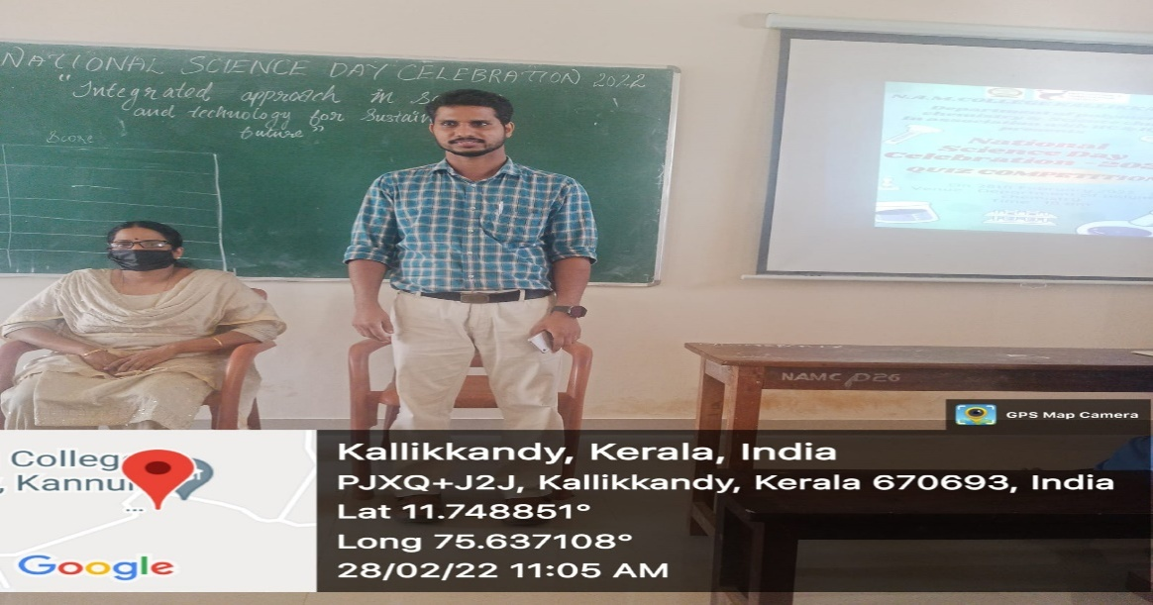 | 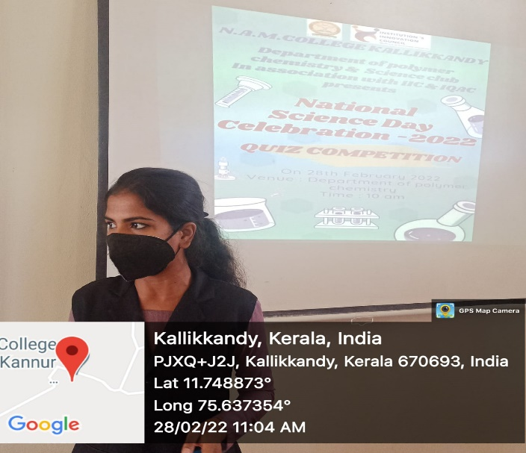
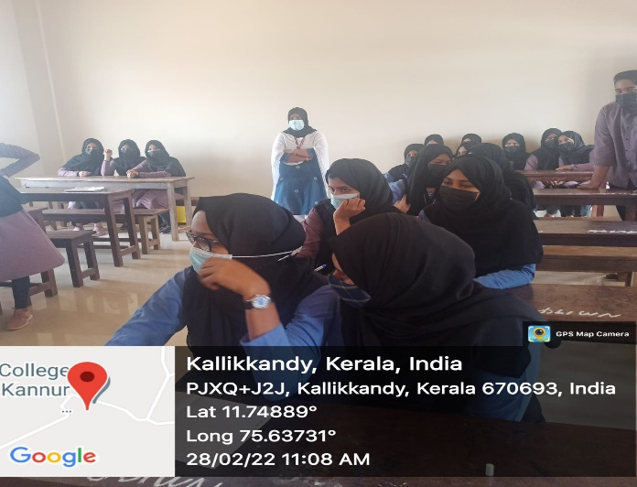 | 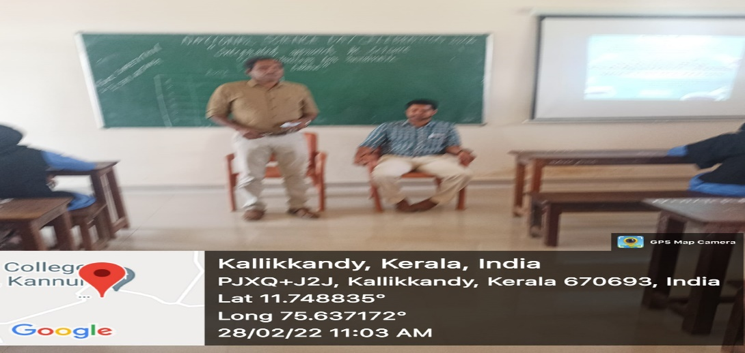
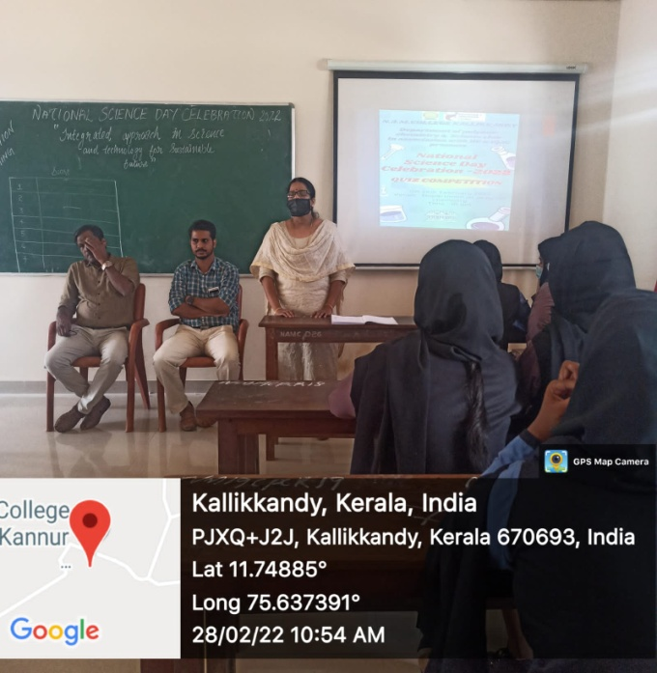 | 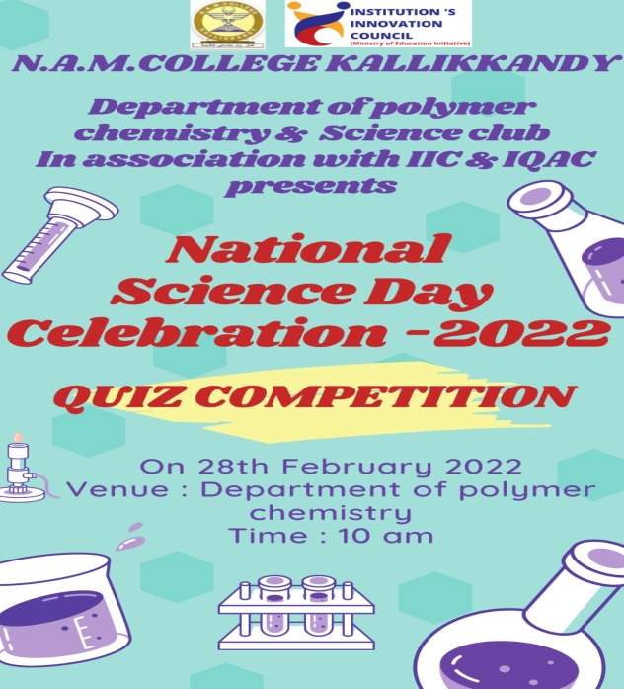
National Science Day Celebration

- Webinar on Career Talk
Department of Polymer Chemistry, in association with IQAC & Career Counselling Cell conducted a webinar on ‘Career and Opportunities in Chemistry’ on 30-09-21 .College Principal Dr. Muhammad Kutty KK inaugurated the programme. Fazil T P, a Polymer Chemist at Qatar Petrochemical Company was the resource person.

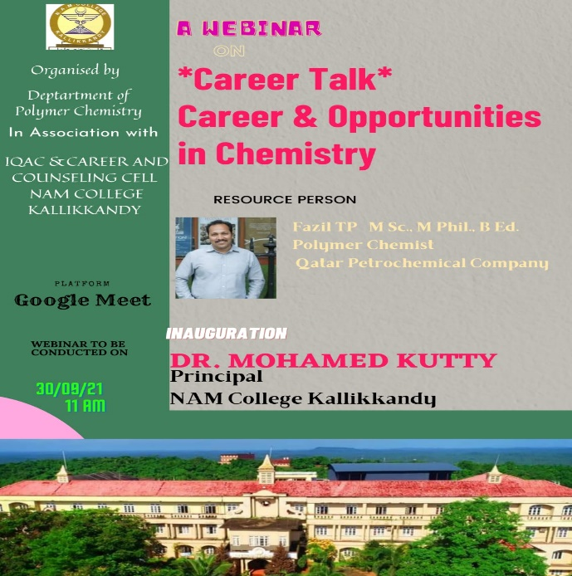

- Career Guidance & Motivation Class

Department of Polymer Chemistry organized a career guidance and motivation class for the 1st , 2nd and 3rd year Polymer Chemistry students . Mr Sameer Oniyil , JCI Trainer and HST , NAM HSS Peringathur was the resource person. He presented the topic “Reframe Your Frames”.
The session was very interesting for the students. They were highly motivated by the resource person. It was a highly effective and interactive session. The students got new inights into their career prospects and about Masters and PhD programmes offered at various reputed higher education institutions.
Dr Muhammed KuttyKK ,Pricipal, inaugurated the function.Dr Muhammed Ismayil K.M chaired the programme. Mrs Hadiya Aboobacker welcomed the gathering annd Akshaya N offered the vote of thanks . Polymer Chemistry Association was also inaugurated on the same day by the chief guest Mr Sameer Oniyil.

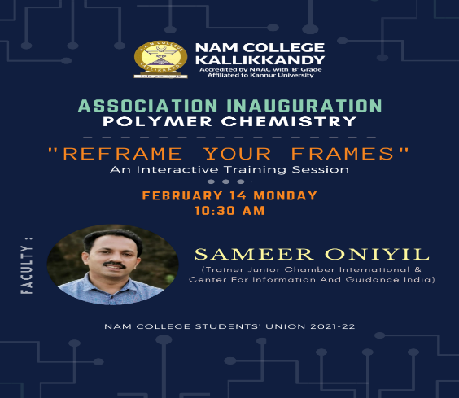

- One Day Seminar on Research Methodology
“Material Chemistry meets Biology”
24-03-22, Seminar Hall

In association with IQAC, Department of Polymer Chemistry organized a one day seminar on the research methodology topic “ Material Chemisrty meets biology” on 24-03-22 at Seminar Hall. Dr Muhammad Kutty KK inaugurated the programme and Dr Muhammed Ismail K.M presided over it.
Dr Safeer Kalathil ,Asst.Professor ,University of Northumbria ,Newcastle, England,was the resource person. He spoke about the use of different types of bacteria in the field of energy production and showed the laboratory that were specially designed for the multi purpose use of waste management and water purification. It was quite an informative and enlightening session. His session was concluded by an interactive session with the students, where the students raised their queries on the higher study opportunites and PhD programmes offered abroad. He answered all the queries and provided data of the various institutions where these courses are offered. Mr. Namshad K.P welcomed the gathering. Around sixty students and four faculty members from the Polymer Chemistry Department attended the programme. Mrs Shabina K.K offered the vote of thanks. The programme ended at 2.30 PM followed by a delicious meals arranged by the students.

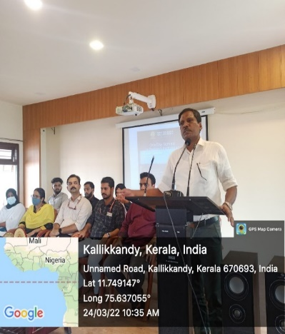 | 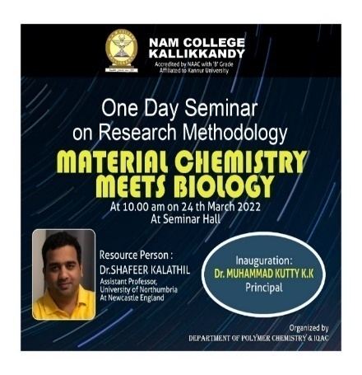
One Day Seminar on Research Methodology

