ASSOCIATION INAUGURATION 2019-20
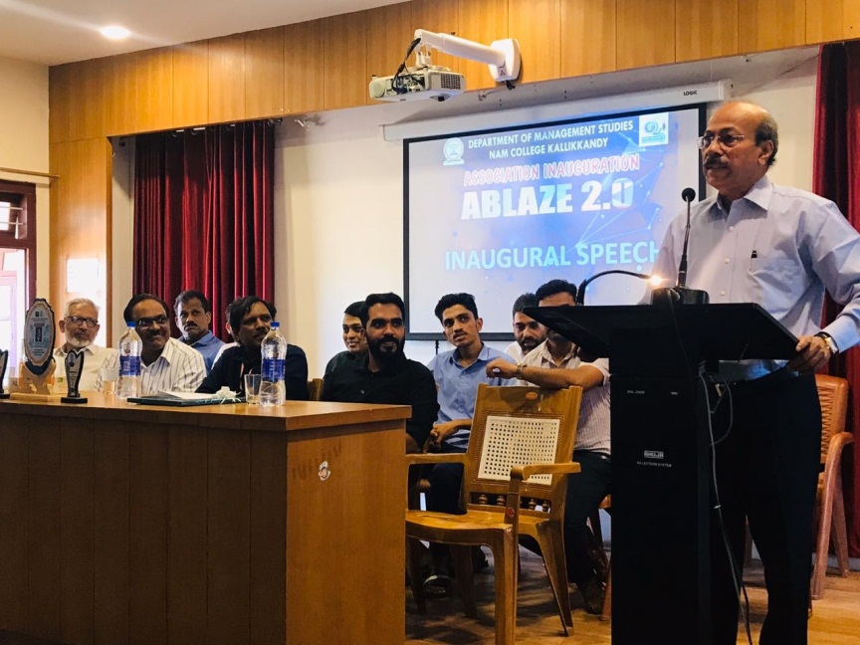
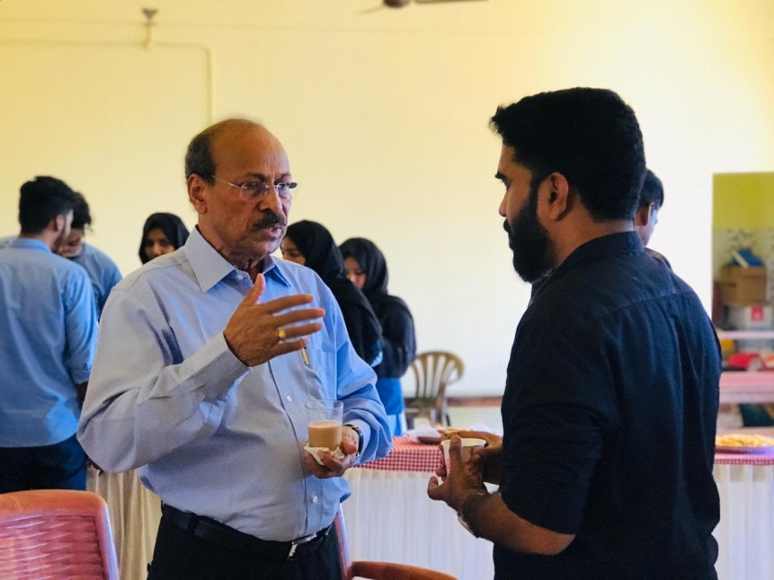
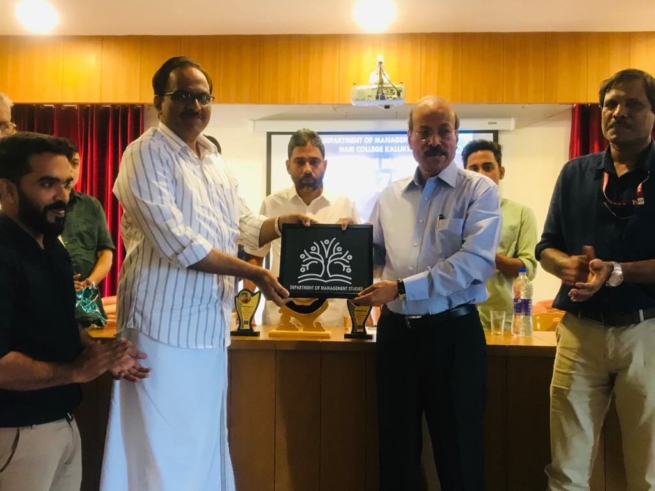
The programme was inaugurated by V. Thulasidas IAS, Managing Director, Kannur International Airport Ltd. The programme was presided by Akbar Mohammad Jamal (Head of Department). Dr. Mohammad kutty KK (Principal) delivered the keynote address. Mr. PP Aboobacker ( Chairman, PARCO Group) launched the Department logo. Dr. Majeesh T ( HOD, PG Dept. of Commerce), Ali Kuyyalil (superintend) , Munfar Kapil( Librarian), Dr. Madhusoodanan ( HOD Physical Education), Abdulla Tarique( Union Chairman), Shifana (Association secretary) felicitated the function. The programme concluded with a food fest organized by the students under the leadership of Shanid P.P, Adil Salah, Shamil K and Nagva Rasheed.
South Indian Management Fest
The Department in association with PG Department of Commerce organized a two day South Indian management fest with prizes over 1.5 lakhs. More than 500 students participated in the programme from over 50 educational institutions from Kerala,Tamilnadu and Karnataka states. The programme was inaugurated by PV Zainudin( Kerala Waqaf board member) and presided over by Dr. Mohmmad Kutty KK(Principal). Dr. Majeesh T( Head, PG Dept Of Commerce), Akbar Mohammad Jamal( Head, Dept of Management Studies), Jb. Khalid Master, Jb. PPA Hameed, Prof Kunhammad, Sameer Parambath, Ismail Pattadam (Muslim Educational Foundation representatives), Anseer, Shahid, Shanid, Abdulla Tarique( student representatives) felicitated the function.
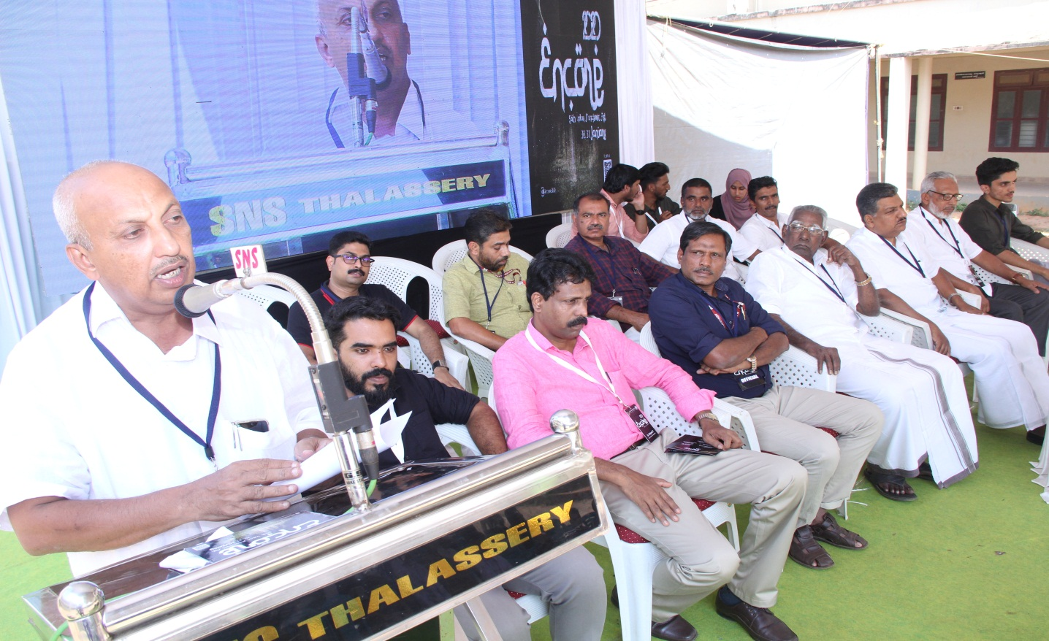
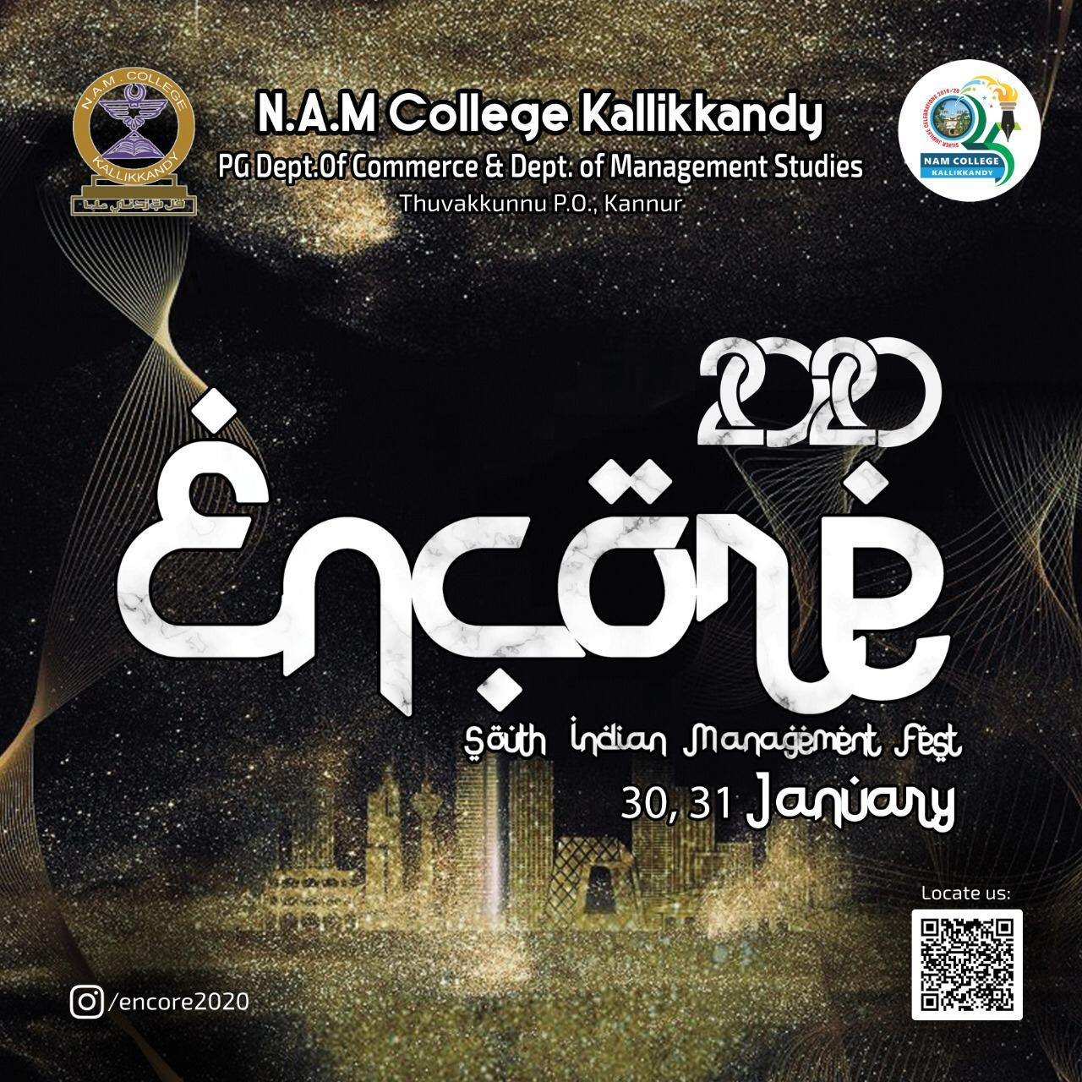

COVID AWARENESS QUIZ
The Department conducted a COVID-19 Awareness Quiz online and

